**Obesity Level prediction in**

**individuals**

**with**

**the use of**

**classification algorithm for building recommender systems**

**By**

**fUNMILOLA ALADEGBOLA**

**2022**

**Table of Contents**

T**ask One: Classification Algorithm** …………………………………………………….…….3

1. Comparison of two classification algorithms ………………………….………….……..3

2. Neural Networks in Python ……………………………………………………………….14

3. Classification in Azure Machine Learning Studio………………………………..….….23

**TASK 1- CLASSIFICATION ALGORITHM**

1. **TITLE**

Obesity level prediction in individuals with the use of classification algorithm for building recommender systems.

1. **INTRODUCTION**

**2.1 Obesity and its definition**

Children, teenagers, and adults are becoming overweight and obese, a worrying trend in many countries, and it's been on the rise for decades (Colmenarejo, 2020). According to him, these conditions are harmful to their health considering the link between them and various life-threatening health conditions and even death.

Kuczmarski, (2007) defined the term obesity as an excessive amount of adipose tissue or body fat that exceeds a threshold considered to be normal or optimal.

This was corroborated by (Médica et al., 2013) where obesity was defined as an excessive accumulation of fat, in which fat content exceeds a predetermined standard based on women, men, height, and age.

He further explained that in the adult population, people who are obese typically have a Body Mass Index (BMI) above 30 kg/m2 (overweight with a value above 27 kg/m2), in contrast, pediatric BMI curves are developed according to age and gender.

(Shashikiran et al., 2004) developed the measurement below for body fat content which was coined as the classification of weight by BMI:



Table 1

According to the WHO, the number of overweight/obese people in the world today has increased to approximately 1,200 million, and a similar number of people still suffer from malnutrition. Unless this current scenario stops by 2040, the entire European population will be overweight (Médica et al., 2013)

Our understanding of how and why obesity develops is incomplete without the integration of social, behavioural, cultural, physiological, metabolic, and genetic factors which can be done through appropriate machine-learning models.

The excellent predictive power of Machine Learning Models makes them important resource tools for designing a suitable approach for prediction (Colmenarejo, 2020), given the recent appearance of large repositories of Electronic Health Records (EHR) that allow the development of models.

**2.2 Importance of Machine Learning algorithms for obesity level prediction**

Statistical models using complex data excel in terms of predictive capabilities, ease of application, and robustness when applied to complex data. However, Machine Learning approaches offer extraordinary advantages and new insights for obesity prediction and prevention. According to (Shashikiran et al., 2004), the advantages are the ability to model complex nonlinear relationships, increased prediction accuracy over statistical models, and modelling electronic health records. In view of this, machine learning offers an incredible opportunity for discovering new information.

**Objective**

Based on the advantages stated above, it is imperative to find out the accuracy of predictions of people's obesity levels based on their eating habits and physical conditions using machine learning algorithms. Decision Trees, Random Forest Classifiers, and Neural Network algorithms will be used to test the accuracy of prediction.

1. **DATASETS**

**3.1 Dataset Information (Source**)

From: UCI Repository

<https://archive.ics.uci.edu/ml/datasets/Estimation+of+obesity+levels+based+on+eating+habits+and+physical+condition>+

**The dataset includes:**

1. An Assessment of obesity levels in individuals from three countries namely Mexico, Peru, and Columbia.
2. Their eating habit and physical conditions, 17 Attributes & 211 Records

A class label called (NObeyesdad) which allows the prediction of data using the values: Insufficient weight, Normal weight, Overweight level I, Overweight level II, Obesity Type I, Obesity type II and Obesity Type III

1. **EXPLANATION AND PREPARATION OF DATA**

**4.1 Problem Statement**:

Can Decision Trees, Random Forest Classifier and Neural Networks in Classification Algorithms provide accurate predictions of people's obesity levels based on their eating habits and physical conditions?

**4.2** **Dataset Name and Environment Used:**

Obesity_data (Jupyter in Anaconda Programme)

**4.3 Independent and Dependent Variable**

|  |  |  |
| --- | --- | --- |
| **S/N** | **INDEPENDENT VARIABLE** | **ACRONYM** |
| 1 | Gender | Gender |
| 2 | Age | Age |
| 3 | Height | Height |
| 4 | Weight | Weight |
| 5 | Family_history_with_overweight | Family_history_with_overweight |
| 6 | FAVC | Frequency of consumption of high calorific food |
| 7 | FCVC | Frequency of consumption of vegetables |
| 8 | NCP | Number of main meals |
| 9 | CAEC | Consumption of food between |
| 10 | SMOKE | Does the individual smoke or not |
| 11 | CH20 | Consumption of water daily |
| 12 | SCC | Monitoring of Calorie intake |
| 13 | FAF | Time using Technology Devices |
| 14 | TUE- | Transportation used |
| 15 | CALC | Consumption of Alcohol |
| 16 | MTRAN | Transportation system |
|  | **DEPENDENT VARIABLE** | **ACRONYM** |
| 17 | NObeyesdad | Estimation of obesity levels in individuals |

Table 2

**4.4 Loading dataset into Jupyter**

**4.4.1 Use pd.read() to load the dataset in Jupyter**



**4.4.2 Total number of rows and columns**

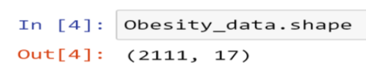

**4.4.3 Data Preparation using dataprep**

**Importing relevant libraries**

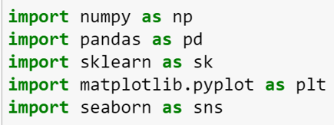

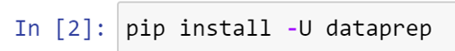

Plot was imported from dataprep.eda get an overview of the dataset

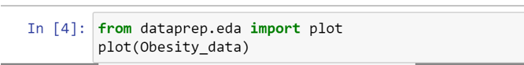

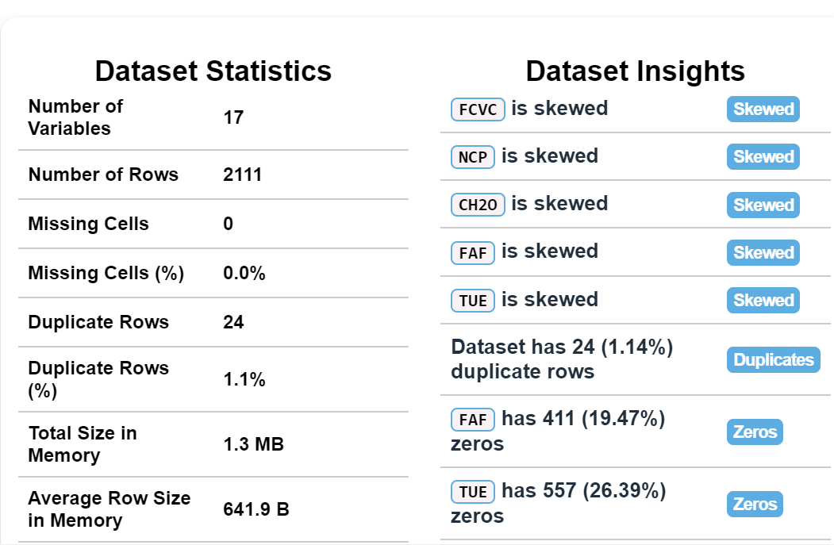

Plot also gives a graphical illustration of the data for a better understanding

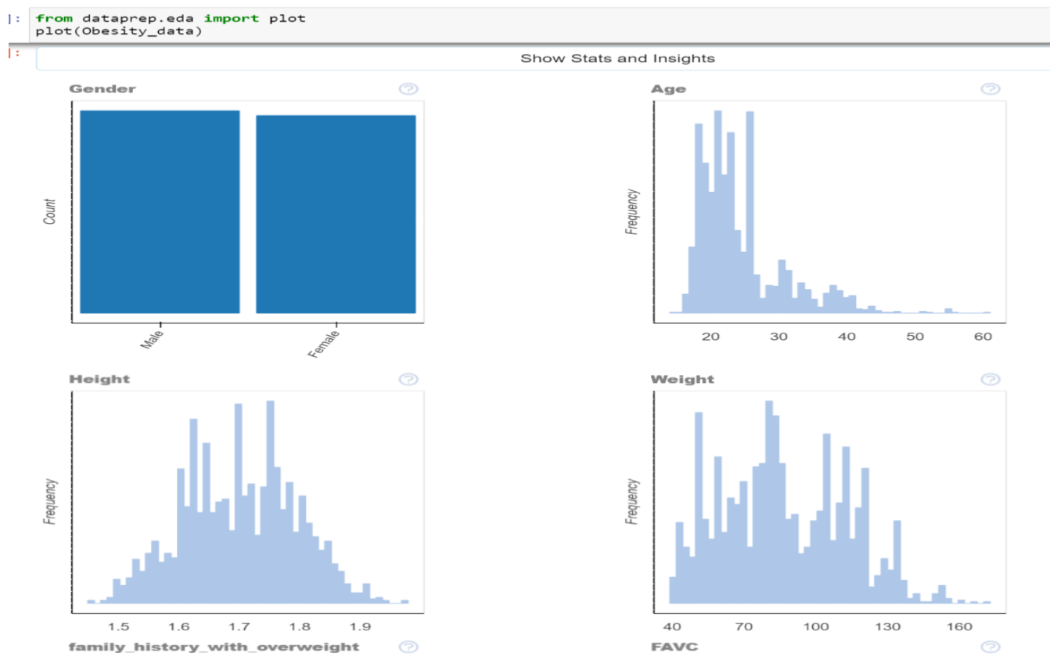



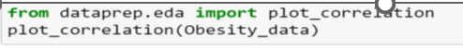

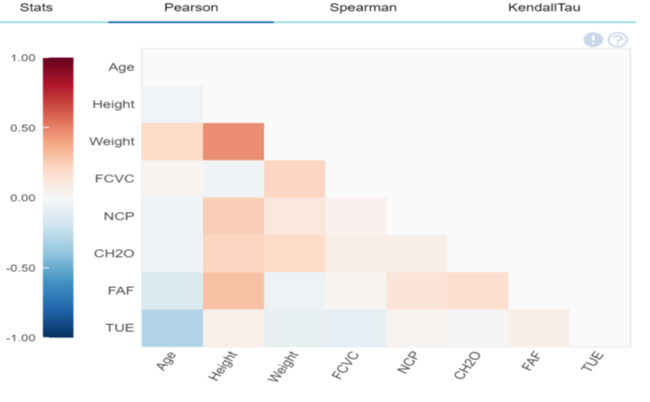

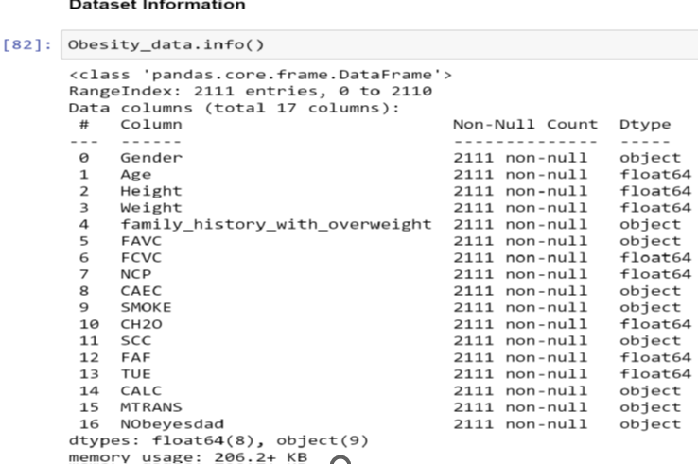

Understanding the data using describe()



**4.4.4 Dealing with missing Values**



**There are no null values in the data. This was checked with isnull().sum()**

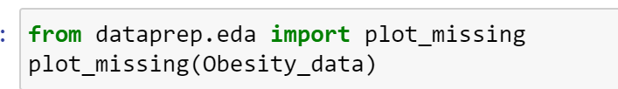

**Importing plot_missing from dataprep also shows that there are no missing values Peradventure missing values exist, SimpleInputer can be used to eliminate null values**



**4.4.5 Exploratory Data Analysis**

Understanding the impact of the dependent variable (Obesity Level) on independent variables

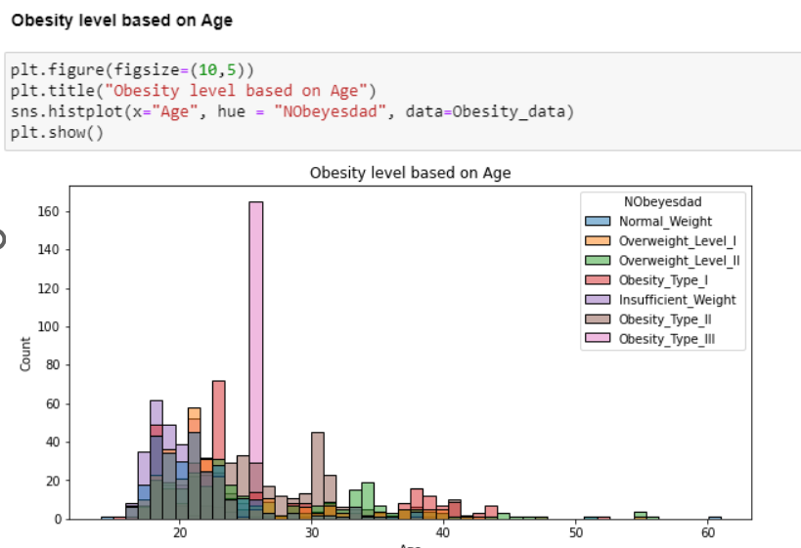

Obesity_Type_III is most prevalent in the age bracket of 26 years

 Obesity_Type_III is most prevalent in the female gender

**The following was generalized from the other graphs:**

* Most people have a history with overweight
* This visualization shows that walking is associated with normal weight while other means of transport are associated with other types of obesity
* Most people do not monitor their calorie intake
* Alcohol intake does not necessarily mean obesity. In fact, people with no or sparse consumption are more prone to obesity
* Smoking does not necessarily cause obesity

**4.4.6 Duplicate Rows**

According to the EDA report, there are 24 duplicate rows that need to be dropped because they are not useful.

The duplicate rows were dropped by using drop_duplicates as shown below

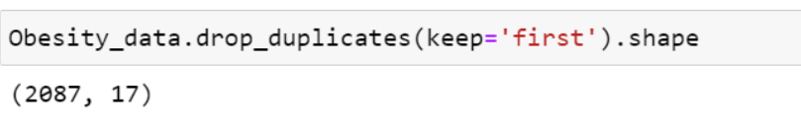

**5.0 IMPLEMENTATION OF DECISION TREES AND**

**RANDOM FOREST CLASSIFICATION IN PYTHON**

**5.1 Class Imbalance**

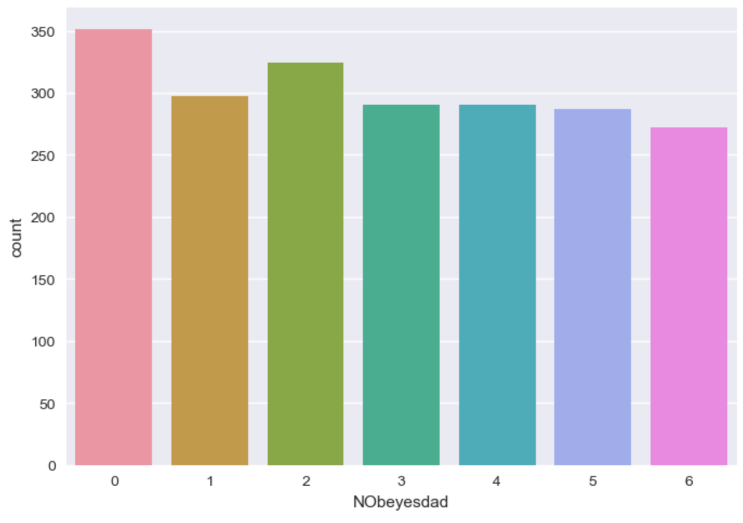

No significant class imbalance. If the class imbalance were to be significant, then random oversampling, undersampling or SMOTE will be carried out.

**5.2 Normalisation**



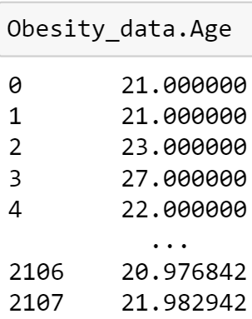

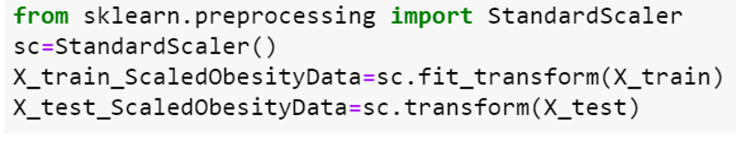

**5.3 Changing Categorical variables in the dataset to Numerical variables**

This will be done with the use of replace and map to show various ways it can be achieved. NObeyesdad column is the class dependent variable while the other columns are the independent variables. loc is used to select the columns to be converted as shown below.



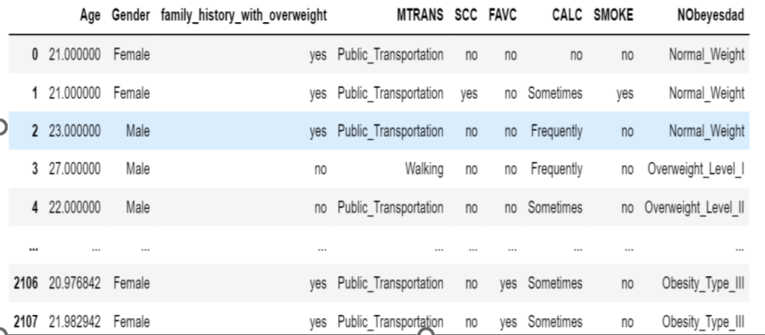

**Both replace and map was used for changing categorical**

**Gender**

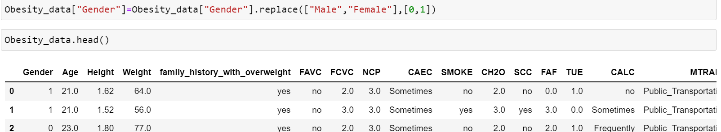

**Transportation**



**All categorical variables have been converted to numeric**

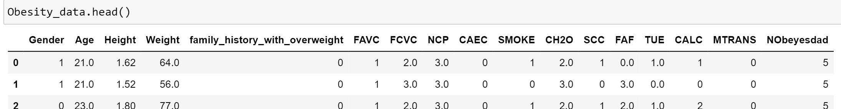

**5.4 Explanation of Experimental procedure**

**5.4.1 Setting and optimization of model hyperparameters during training**

**Computation of pairwise correlation of all columns**.

It uncovers all the potential relations of interest to determine if they are significantly different from each other.

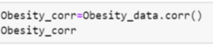

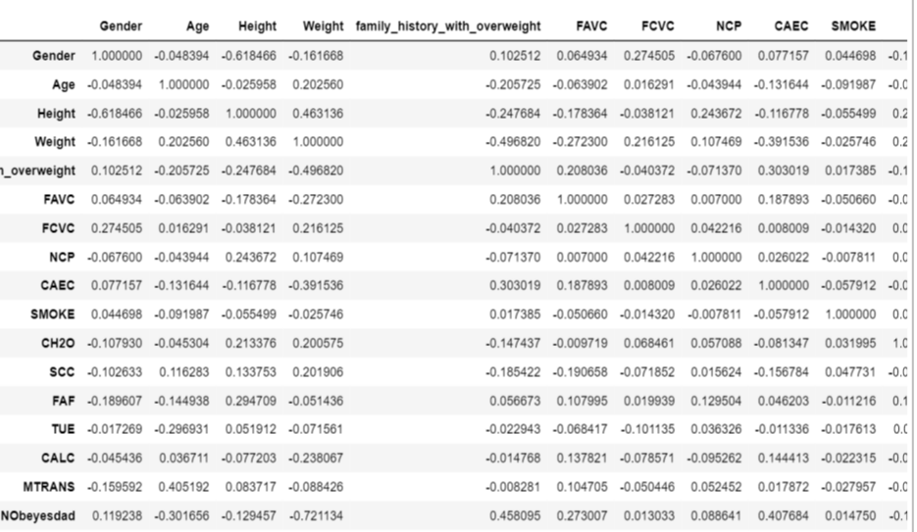

* + 1. **Heatmap showing correlation of variables**

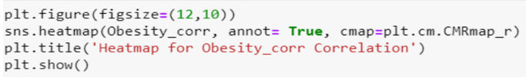

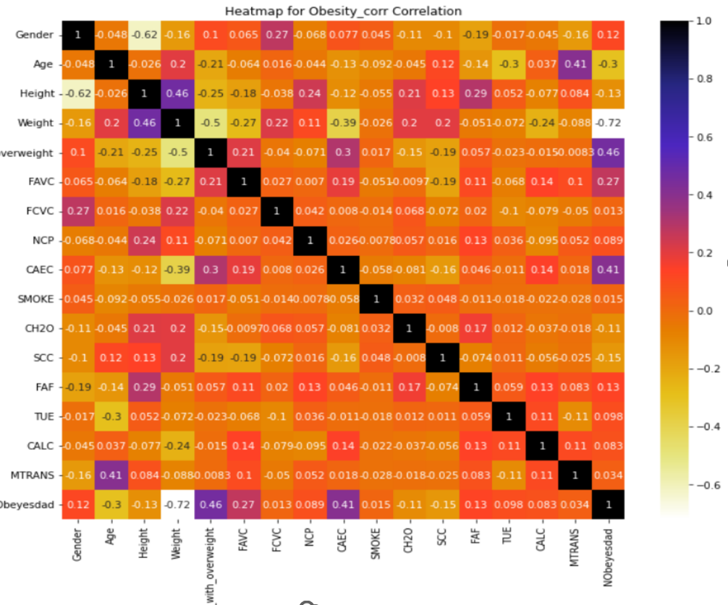

No major correlation exists between the columns. Gender for example has a negative correlation with Age, Height, Weight, NCP, CH20, SCC, TUE, CALC, and MTRANS.

* -ve1 indicates a perfect negative linear correlation between two variables
* 0 indicates no linear correlation between two variables
* +ve 1 indicates a perfect positive linear correlation between two variables

**5.5 Brief description of the algorithms used**

**Decision Trees**

According to Charbuty & Abdulazeez, (2021), “Decision Tree is a classification model in Data Mining whereby the nodes and branches are composed of each tree, and each node represents features in a category to be classified”. Each subset defines a value that can be taken by the node as shown below:

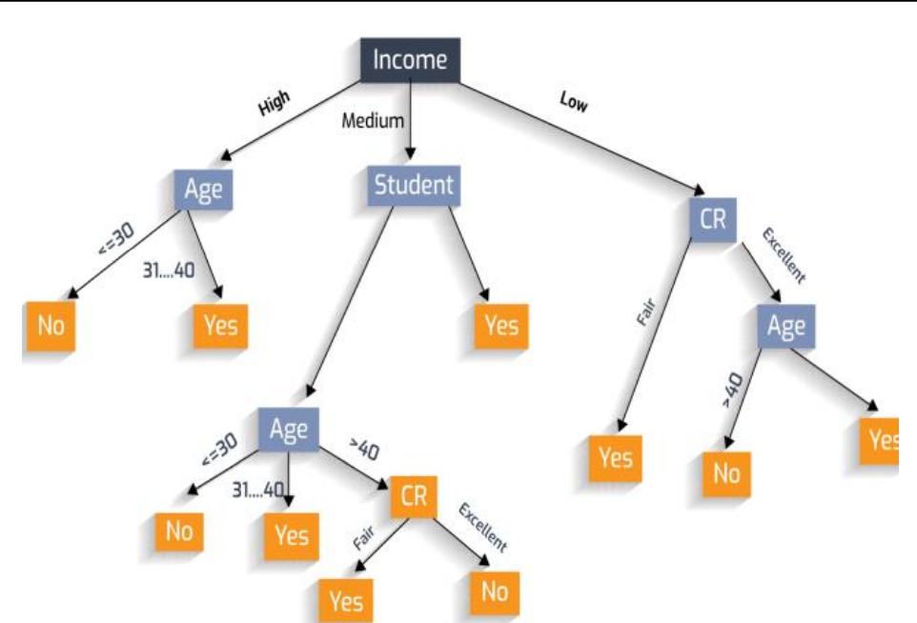

**Random Forest Classifier**

An efficient learning algorithm is Random Forest which is a statistical- or machine-learning algorithm for prediction (Schonlau & Zou, 2020). He further stated that Random decision forests “easily adapt to nonlinearities found in the data and therefore have the ability to predict data more accurately.

**Neural Networks**

According to Picton (1994), “Neural Network is a network of interconnected elements which creates machines that work in a similar way to the human brain by building these machines using components that behave like biological neuro”.

**5.6 The application of data-mining techniques to the dataset**

The major aim of this experiment under the classification algorithm is to predict obesity levels in individuals (x) based on their eating habits and physical features(y). Therefore, the data needs to be sliced into input and output, then the training set and Test set as shown below:

**Training and Testing Dataset**

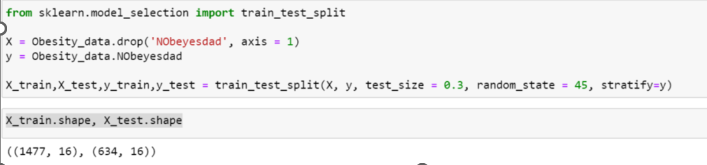

Spliitng the data shows there are 1477 X_trains, 16 X_tests, 634 y_train and 16 y_tests

by importing train_test_split from sklearn.model_selection

**5.7 Scaling X dataset**

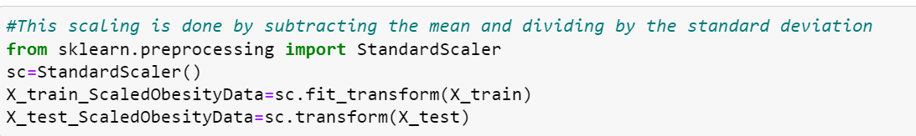

**Decision Tree and Random Forest Classifier**

**5.7.1 Decision Tree**

Tree is imported from sklearn to fit the training dataset in order to make the y_prediction

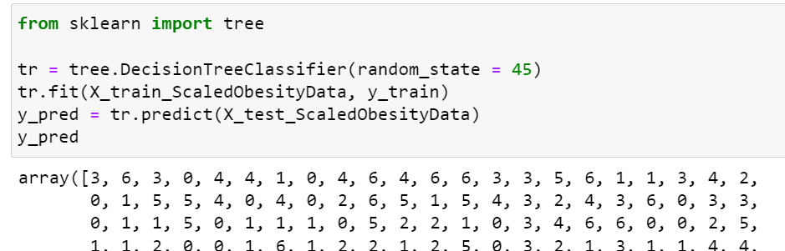

**5.7.2 Random Forest Classifier**

RandomForestClassifier was imported from sklearn to fit the training dataset in order to make the y_prediction

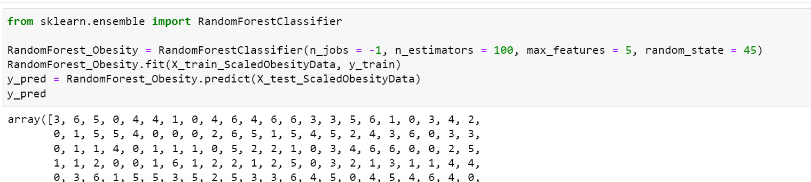

**6.0 IMPLEMENTATION OF NEURAL NETWORKS IN**

**PYTHON**

**6.1 Importing the required libraries and Loading the dataset**



**6.2 Understanding the dataset under Neural Networks**

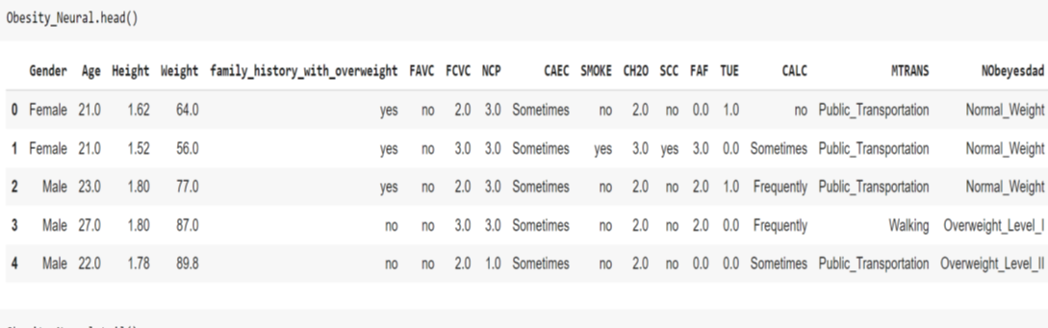

**Counting of unique values**

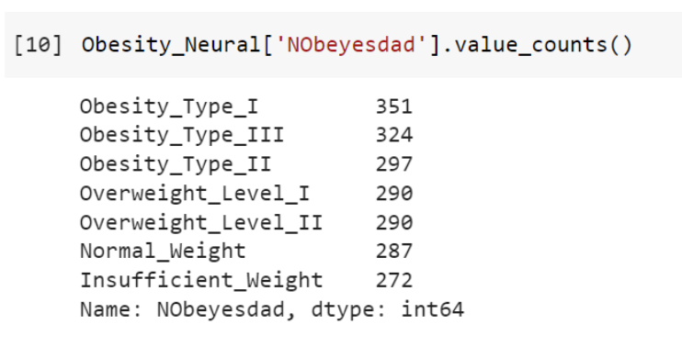

**6.3 Checking for class imbalance under Neural Networks**

There is no significant imbalance in the parameters for the class Label

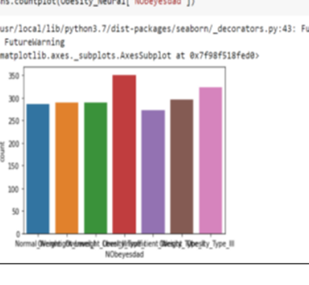

**6.4 Data Cleaning and Preparation for Neural Network**

**Removal of duplicate rows**

There are 24 duplicate rows which are removed by using drop function

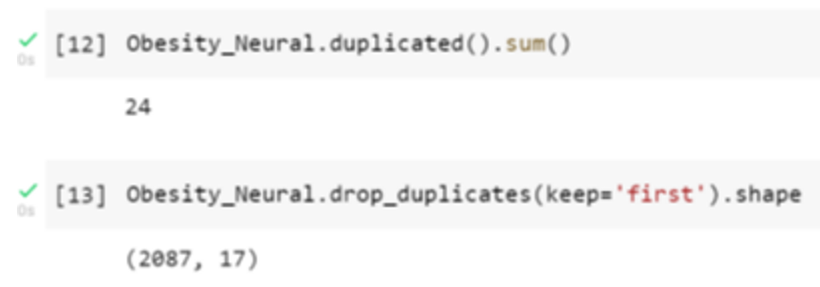

**6.5 Changing categorical variables into numeric variables in**

**Neural Network**

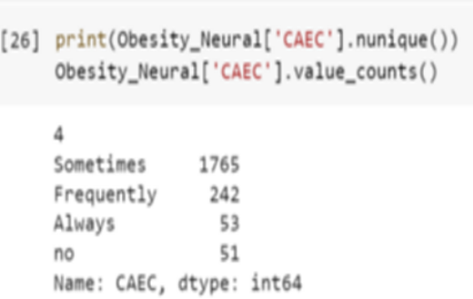



**Checking to see that all categorical variables has been converted to numeric**

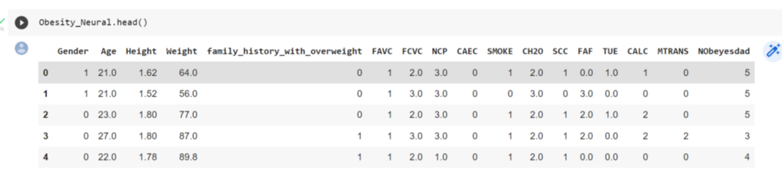

**6.6 Application of data mining techniques to the dataset in Neural**

**Networks**

**6.6.1 Setting the X and y datasets**

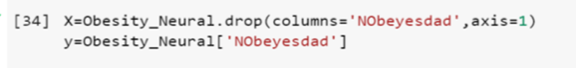

**Showing the columns set as X**

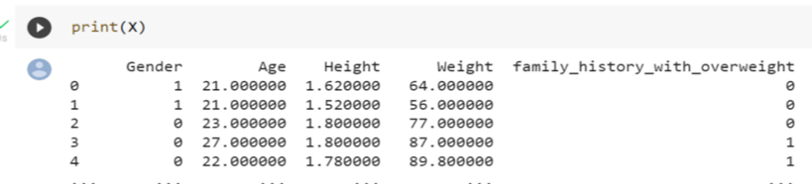

**Showing the column set as y (Class label “NObeyesdad”)**

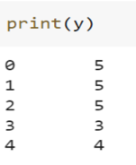

**6.6.2 Training and Testing datasets in Neural Networks**

**Splitting the test set and train set by using train_test_split imported from sklearn.model_selection**

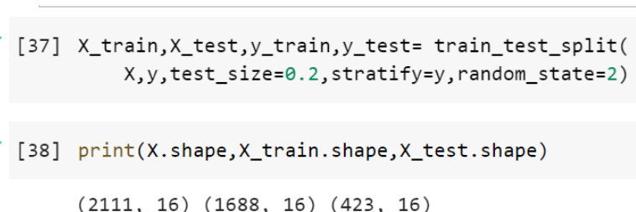

**Normalisation**

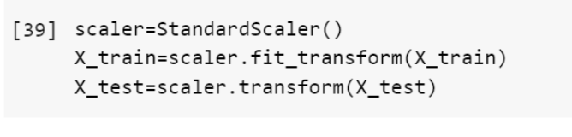

**Building and training the model using Keras by adding layers**

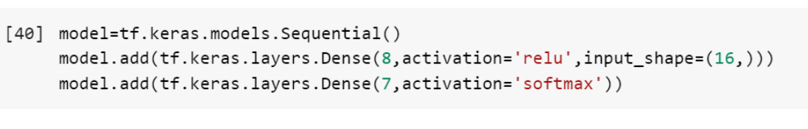

This is a simple feedforward network whereby a dense layer is used. This means each neuron in the layer is connected to each neuron in the previous layer. The number of neurons each layer will contain is specified by the activation function which is 8 in this case.

OBeyesdad has a class code of 16 input variables hence the size of the shape. Finally, the number of neurons must be the same as the number of classes.

The number of classes are 7, hence the size of the neuron in the final layer. Since this is a multiclass classification problem, a softmax activation function is used in the final layer which ensures the total value across the output sums to 1

**Compiling the model by selecting an optimizer and loss function**

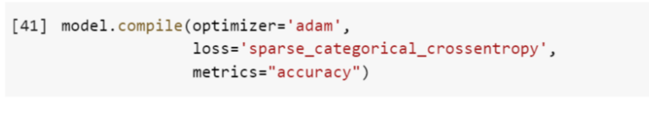

An optimizer determines how fast the network learns while the loss function is used to calculate how big the error is in the neural network’s predictions. Adam is a common optimizer.

**Summary of the Neural Network built**

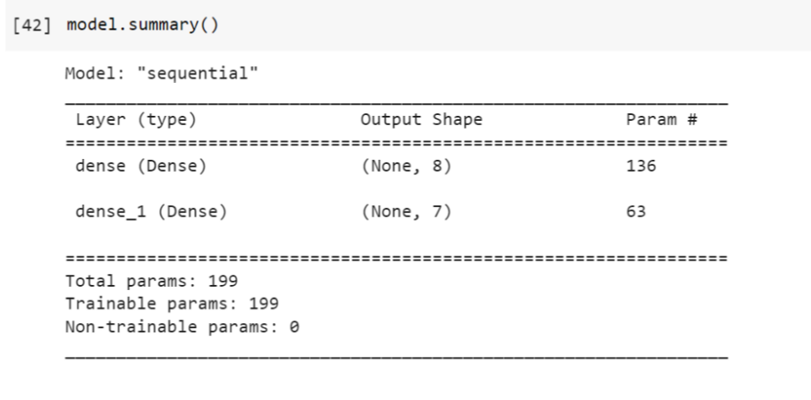

**Use of fit method to train the model using batch_size, epochs, verbose and**

**validation_split**

* Batch_size: No of training samples fed through the network in one go before updating
* Epoch: All the training data is passed through the network at once
* Verbose: determines how much information we are given on the training and setting this to 2 outputs more detailed information as we go through the training
* Validation_split: This determines how much data is left out of the training data and is used to calculate the validation metrics during each epoch

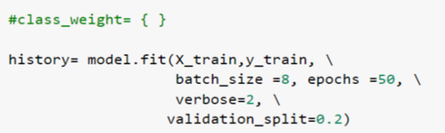

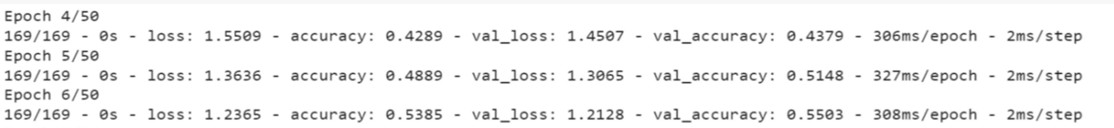

The class imbalance is insignificant, hence there is no need to bother addressing this. If it was significant, then this can be addressed by training the classes in inverse proportion to the % of observations in that class.

**7.0 RESULTS ANALYSIS AND DISCUSSION FOR DECISION TREES, RANDOM FOREST CLASSIFICATION, AND NEURAL NETWORKS**

**DECISION TREES**

**Visualization of the result in Decision Tree**

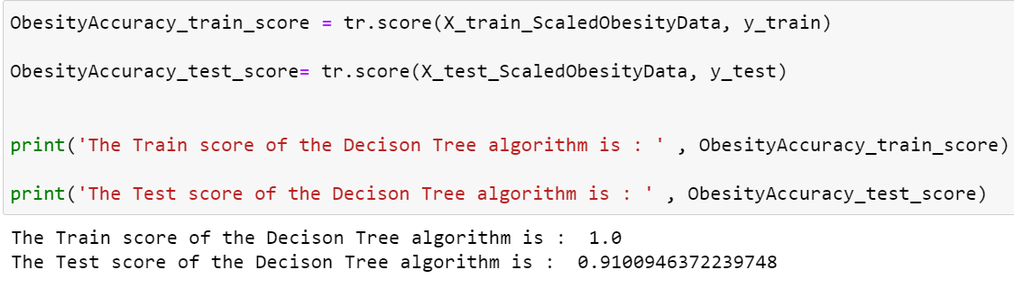

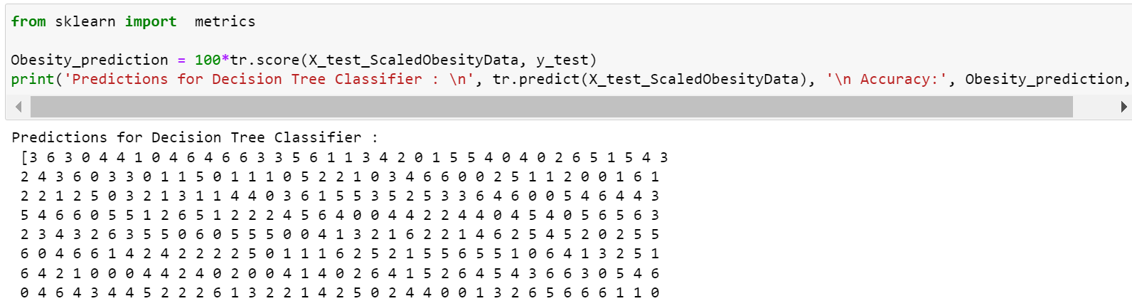



**RANDOM FOREST CLASSIFICATION**

**Visualization of the result in Random Forest Classification**

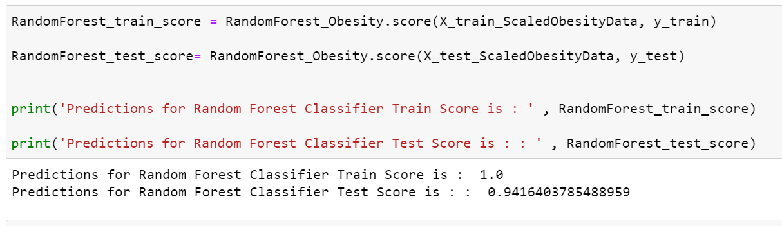

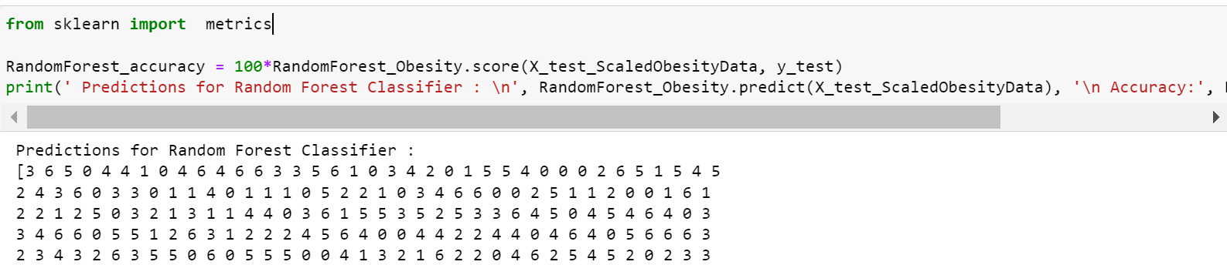

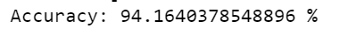

**NEURAL NETWORKS**

**Visualisation of the result in Neural networks**

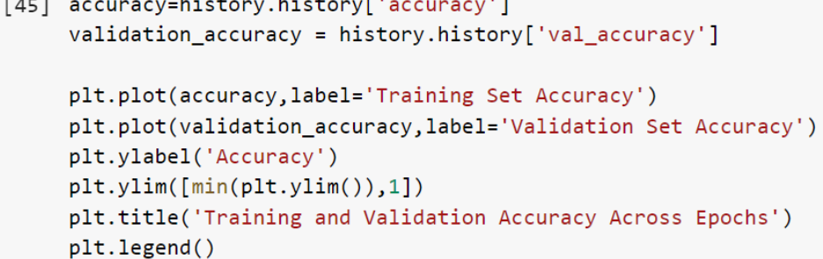

Training and validation Accuracy

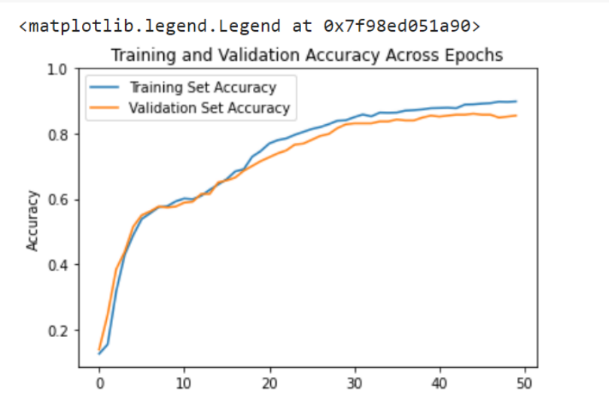

**The result could be improved upon since the graph shows the training set Accuracy line is higher than the Validation set accuracy line**

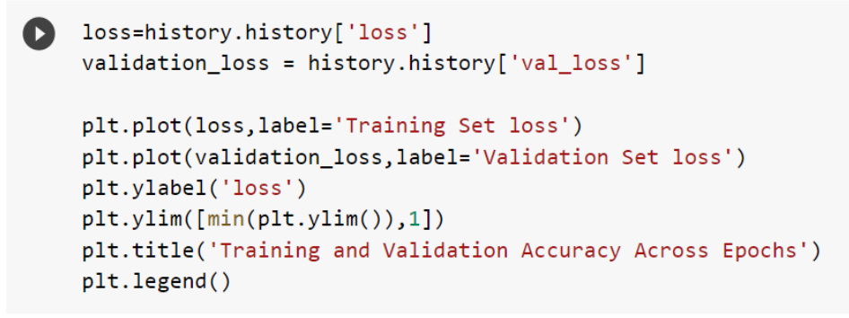

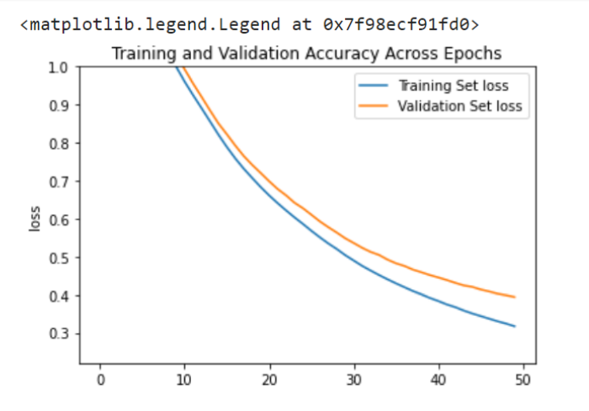

* 1. **Explanation and justification of the performance metric chosen to use to evaluate the model(s).**

According to (Colmenarejo, 2020) “several concepts are used to characterize the performance of the model below, depending on whether the real category is “+” or “−“, and whether the predicted category is “+” or “−“.

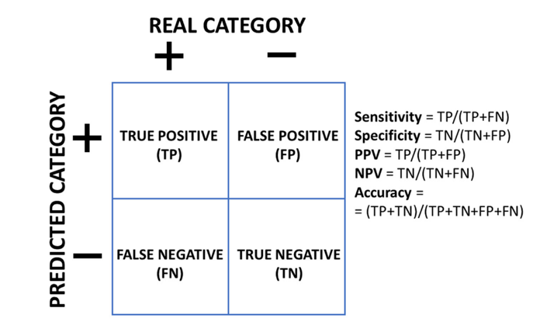 (Colmenarejo, 2020)

“Positive Predictive Value(PPV) or precision is the proportion of predicted positives that are real positives, and Negative Predictive Value(NPV) is the proportion of predicted negatives that are real negatives. Accuracy is the total proportion of correct predictions of all the predicted data. A perfect model would have all these measures equal to 1. Obviously, this is almost never the case, and we have to cope with some proportion of errors.”

**7.1.1 DECISION TREES**

**Classification Report Confusion Matrix**

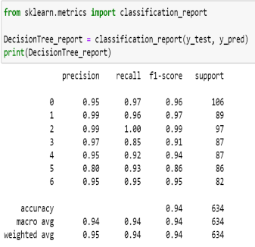

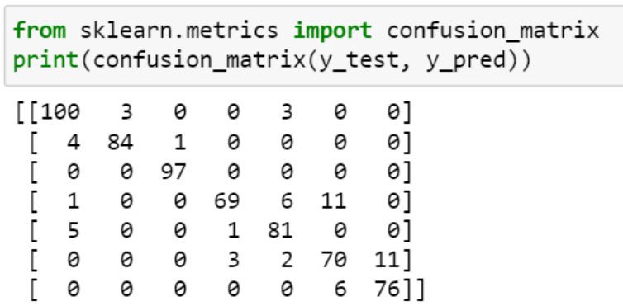

The classification report shows precision as 0.94 under Decision Trees while the confusion matrix also shows that out of all Obesity_Type_I, 100 was predicted correctly for example.

**7.1.2 RANDOM FOREST CLASSIFIER**

**Classification Report Confusion Matrix**

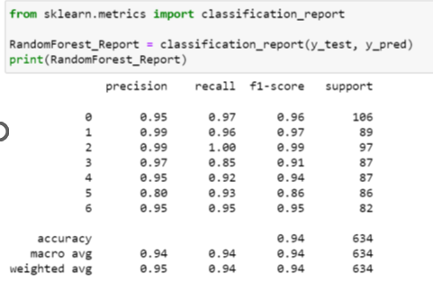 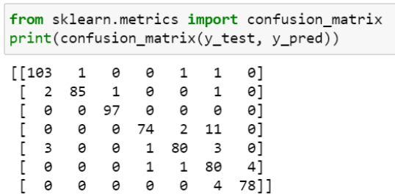

The classification report shows precision as 0.94 under Random Forest Classifier while the confusion matrix also shows that out of all Obesity_Type_I, 103 was predicted correctly for example.

7.1.3 **NEURAL NETWORKS**

**Classification Report Confusion Matrix**

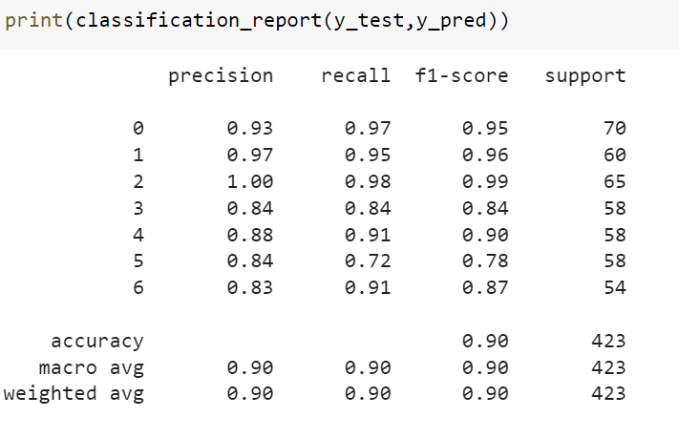 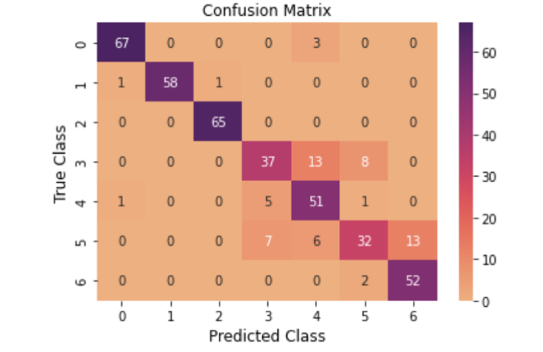

The classification report shows precision as 0.90 under Neural Networks while the confusion matrix also shows that out of all Obesity_Type_I, 67 was predicted correctly for example.





**7.2 Ethical, legal, or professional considerations in using machine learning and data mining on the datasets selected.**

According to (Saltz J et al., 2019), A lot of big ethical issues have arisen from Machine learning which includes prejudice based on race and sexual orientation. prognosis and disclosure of people’s private lives and values or faith.

As machine learning becomes more embedded in our everyday lives such as public safety, analysis of creditworthiness, and analysis of health diagnoses such as obesity level predictions, it tends to pry into people’s intimate details.

Thus, those who use machine learning users must be sensitive to the following listed by Saltz J et al., 2019):

* Laws and regulations intended for the project being handled
* Achievement of ethical accountability
* Impingement of legal rights of people through the use of data
* Availability of data for its intended ethical use?
* Bias minimization in the data model
* Achievement of transparency in the data model.

**8.0 CONCLUSION**

The objective was to find out if Decision Trees, Random Forest Classifier and Neural Networks in Classification Algorithms could give accurate predictions of people's obesity levels based on their eating habits and physical conditions.

From the analysis above, the accuracy of the Decision Tree Algorithm is 91.0% while that of the Random Forest Algorithm is 94.1% Showing that the Random Forest Algorithm was more accurate in its prediction than Decision Trees.

However, comparing these two algorithms to Neural Networks while taking classification reports into account, both Decision Tree and Random Forest have a precision (Accuracy Macro Average) of 0.94% while Neural Networks have 0.90%. This shows both Algorithms were more accurate in their prediction than Neural Networks. The graph in training and validation accuracy in Neural Networks shows that the result could be improved upon since the training set Accuracy line is higher than the Validation set accuracy line.

**9.0 AZURE MACHINE LEARNING STUDIO**

**Obesity Data in Azure**

An analysis of Obesity Data used for Decision Trees, Random Forests and Neural Networks will be done in Azure to find out the accuracy of prediction.

**Loading dataset called Obesity_data_new**

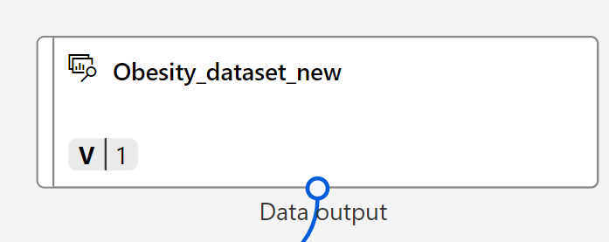

**Previewing the loaded data**

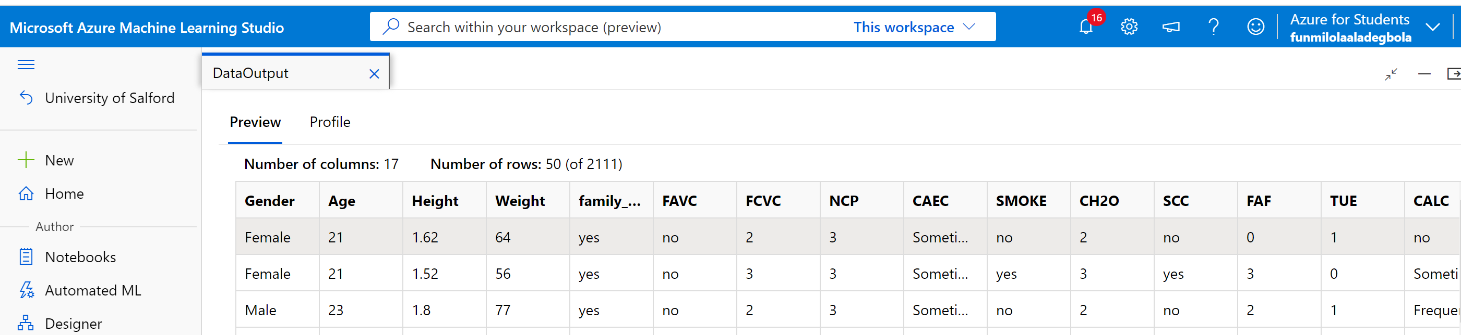

**Pre-processing transformations to the data**

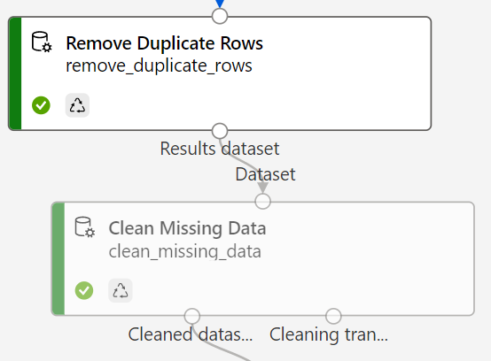



**Previewing editted metadata**

**Encoding of categorical values**

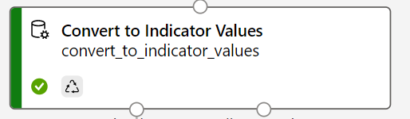 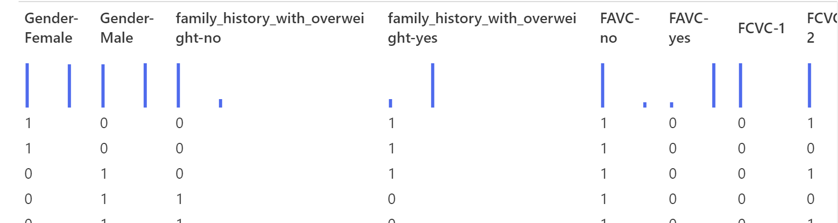

**Normalizing data to prevent columns with large values from dominating model training**

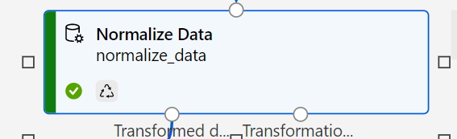 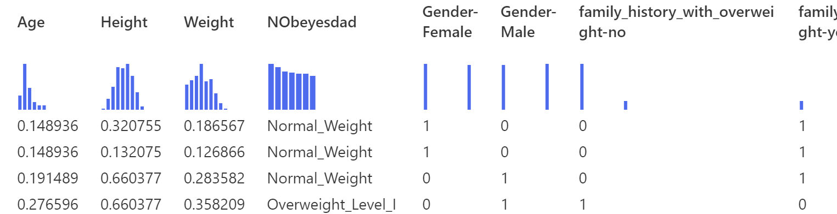

**Python Script to Encode class label NObeyesDad**

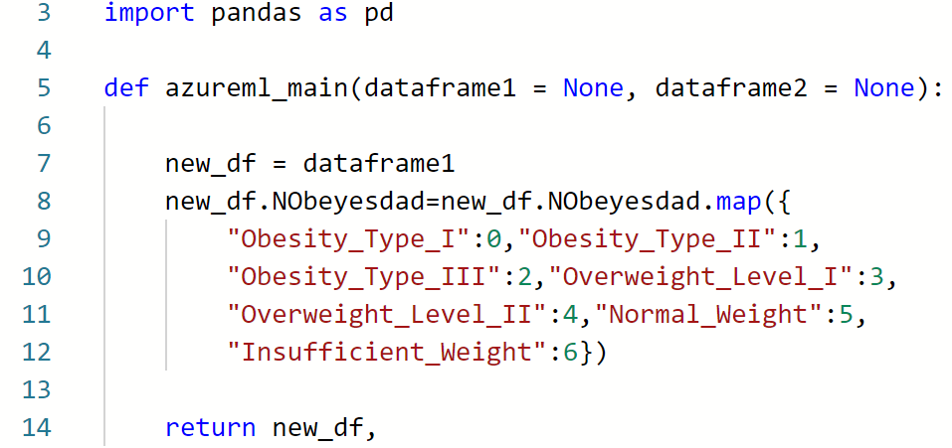

**Splitting the data, applying Multiclass Neural network, and Training the dataset**

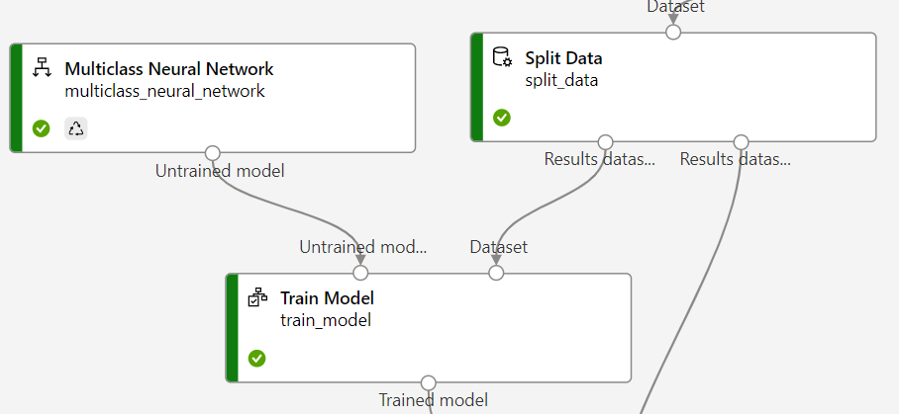

**Scoring the Model**

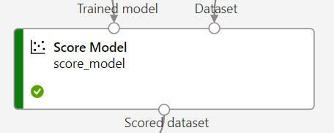 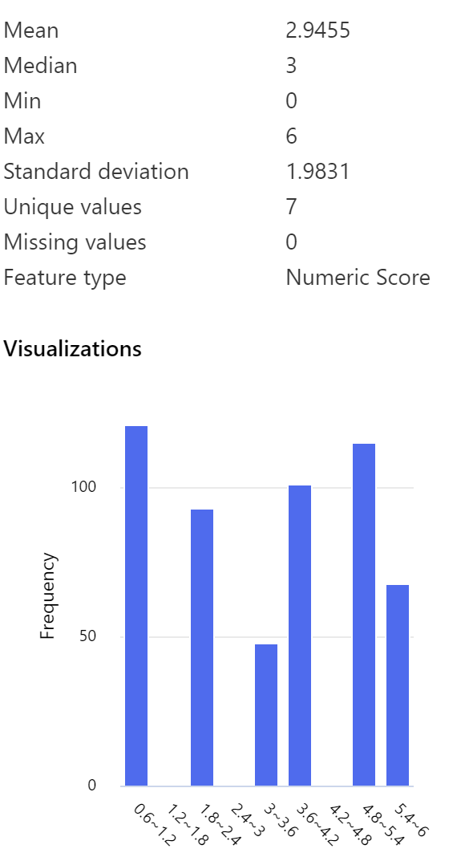

**Model Evaluation**

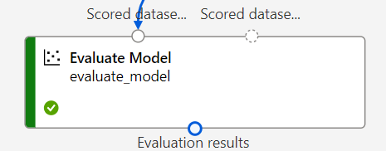

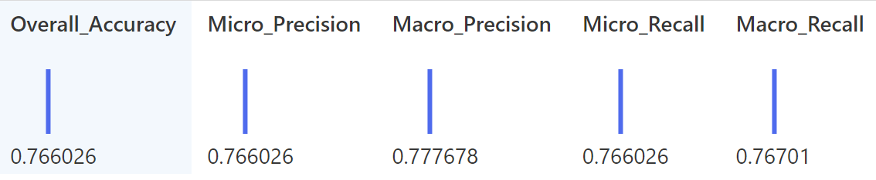

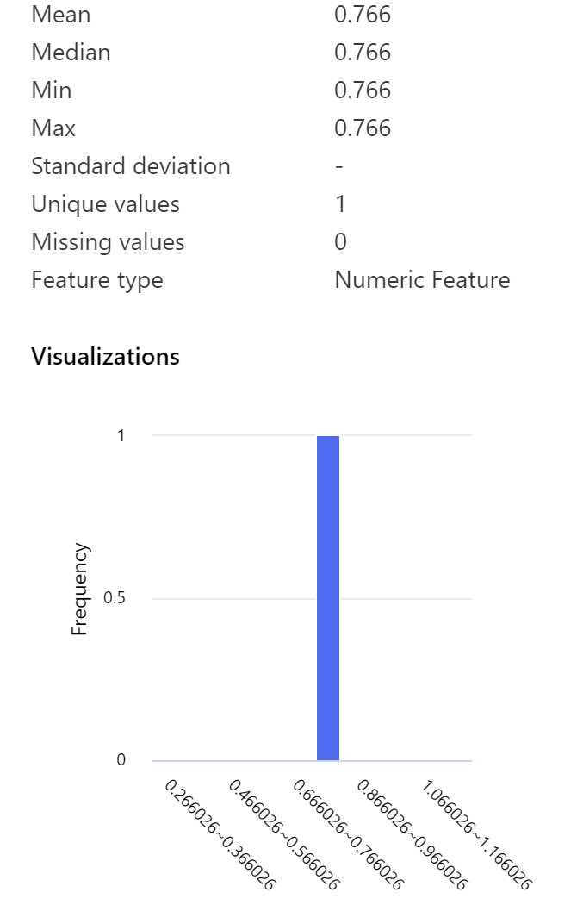

**The accuracy of the trained model is 0.76% which is lower than Decision Trees and Neural Networks.**

**The Model at a glance in Azure Machine Learning Studio.**

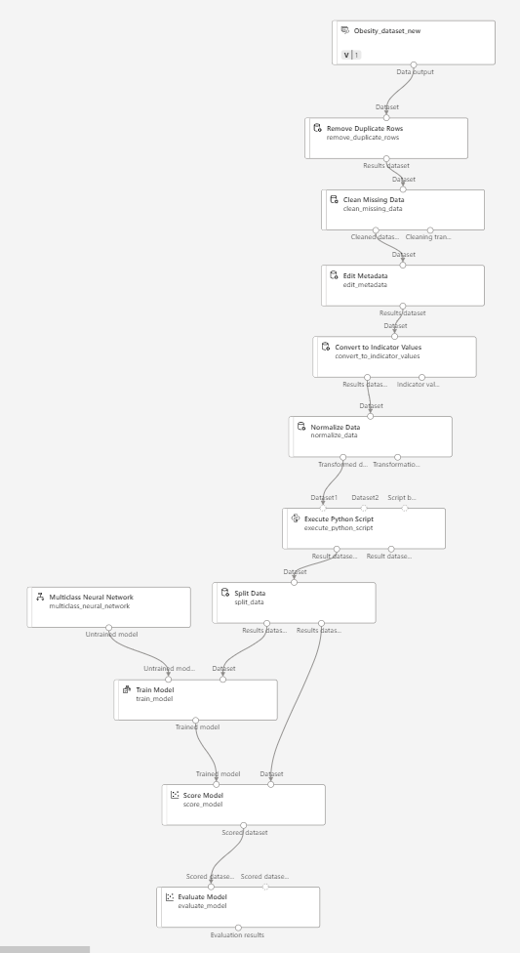

**REFERENCES**

Azeez, N. A., Ayemobola, T. J., Misra, S., Maskeliūnas, R., & Damaševičius, R. (2019). Network intrusion detection with a hashing based apriori algorithm using Hadoop MapReduce. Computers, 8(4). <https://doi.org/10.3390/computers8040086>

Charbuty, B., & Abdulazeez, A. (2021). Classification based on decision tree algorithm for machine learning. *Journal of Applied Science and Technology Trends*, *2*(01), 20-28.

Colmenarejo, G. (2020). Machine learning models to predict childhood and adolescent obesity: A review. In *Nutrients* (Vol. 12, Issue 8, pp. 1–31). MDPI AG. <https://doi.org/10.3390/nu12082466>

Dasseni Vassilios Verkios Ahmed K Elmagarmid, E. S., Bertino, E., Dasseni Vassilios Verykios Ahmed K Elmagannid Elisa Bertino, E. S., Dasseni, E., Verykios, V. S., & Elmagarmid, A. K. (2000). *Hiding Association Rules by Using Confidence and Support Hiding Association Rules by Using Confidence and Support Hiding Association Rules by Using Confidence and Support*. <https://docs.lib.purdue.edu/cstech/1488>

Ghosh, S., Roy, S., & Bandyopadhyay, S. K. (2012). A tutorial review on Text Mining Algorithms. *International Journal of Advanced Research in Computer and Communication Engineering*, *1*(4),

Hand, D. J. (2007). Principles of Data Mining. In *Drug Safety* (Vol. 30, Issue 7).

Gunadi, G., & Sensuse, D. I. (2012). Penerapan Metode Data Mining Market Basket Analysis Terhadap Data Penjualan Produk Buku Dengan Menggunakan Algoritma Apriori Dan Frequent Pattern Growth ( Fp-Growth ) : Telematika, 4(1),118–132.

Hipp, J., Güntzer, U., & Nakhaeizadeh, G. (2000). Algorithms for association rule mining—a general survey and comparison. *ACM sigkdd explorations newsletter*, *2*(1), 58-64.

Informatization, BCGIn 2011, 475–478. <https://doi.org/10.1109/BCGIn.2011.125>

Kaur, M., & Kang, S. (2016). Market Basket Analysis: Identify the Changing Trends of Market Data Using Association Rule Mining. *Procedia Computer Science*, *85*, 78–85. <https://doi.org/10.1016/j.procs.2016.05.180>

Kuczmarski, R. J. (2007). What is obesity? Definitions matter. In *Handbook of Obesity Prevention* (pp. 25-44). Springer, Boston, MA.

Li, L., & Zhang, M. (2011). The strategy of mining association rule based on cloud computing. Proceedings of the 2011 International Conference on Business Computing and Global

Liu, X., Zhao, Y., & Sun, M. (2017). An Improved Apriori Algorithm Based on an Evolution-Communication Tissue-Like P System with Promoters and Inhibitors. Discrete Dynamics in Nature and Society, 2017. <https://doi.org/10.1155/2017/6978146>

MERINO, L. F. A., APERTE, E. A., BARTRINA, J. A., TORRES, J. M. Á., LAÍN, S. A., CORTÉS, S. B., ... & ZAMORA NAVARRO, S. A. L. V. A. D. O. R. (2013). Obesity and sedentarism in the 21st century: what can be done and what must be done?. *Nutr Hosp*, *28*(Supl 5), 1-12.

Niklas Lang. (n.d.). *Association Rules with Apriori Algorithm*. Retrieved October 27, 2022, from <https://towardsdatascience.com/association-rules-with-apriori-algorithm-574593e35223>

Picton, P. (1994). What is a neural network?. In *Introduction to Neural Networks* (pp. 1-12). Palgrave, London.

Prainsack, B., & Steindl, E. (2022). Legal and Ethical Aspects of Machine Learning: Who Owns the Data?. In *Artificial Intelligence/Machine Learning in Nuclear Medicine and Hybrid Imaging* (pp. 191-201). Springer, Cham.

Raorane, A. A., Kulkarni, R. V., & Jitkar, B. D. (2012). Association rule–extracting knowledge using market basket analysis. *Research Journal of Recent Sciences ISSN*, *2277*, 2502.

Saltz, J., Skirpan, M., Fiesler, C., Gorelick, M., Yeh, T., Heckman, R., ... & Beard, N. (2019). Integrating ethics within machine learning courses. *ACM Transactions on Computing Education (TOCE)*, *19*(4), 1-26.

Schmitz, C., Hotho, A., Jäschke, R., & Stumme, G. (2006). Mining Association Rules in Folksonomies. Data Science and Classification, 261–270. <https://doi.org/10.1007/3-540-34416-0_28>

Schonlau, M., & Zou, R. Y. (2020). The random forest algorithm for statistical learning. *The Stata Journal*, *20*(1), 3-29.

Santoso, M. H. (2021). Application of Association Rule Method Using Apriori Algorithm to Find Sales Patterns Case Study of Indomaret Tanjung Anom. *Brilliance: Research of Artificial Intelligence*, *1*(2), 54–66. <https://doi.org/10.47709/brilliance.v1i2.1228>

Shashikiran, U., Sudha, V., & Jayaprakash, B. (2004). What is obesity. *Med J Malaysia*, *59*(1), 131.

Sornalakshmi, M., Balamurali, S., Venkatesulu, M., Navaneetha Krishnan, M., Ramasamy, L. K., Kadry, S., Manogaran, G., Hsu, C. H., & Muthu, B. A. (2020). Hybrid method for mining rules based on enhanced Apriori algorithm with sequential minimal